Name:

ID:

M6 Assignment C1-03 V2

Submit here: https://docs.google.com/forms/d/e/1FAIpQLSeRNAfSqVSNlfq4apWlOugUjgwM_kqs-vQJFTn4qNIaO71fWQ/viewform

Part 1:

1. Create the following using HTML, CSS, and JavaScript. When you hover over each element in the table, the background color should change to cyan. The names should be colored red and be bold. The countries should be colored orange and italicized:



1. Create the following with HTML, CSS, and JavaScript. When you click on each box, the background color of the web page should change to the color written on the box:

Before click:

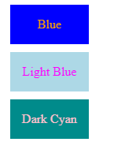

After clicking on each color:

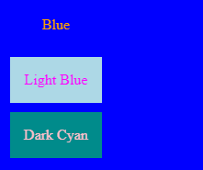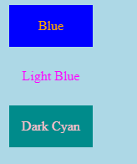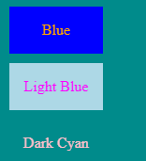

1. Recreate the following using HTML, CSS, and Javascript. The websites should be hyperlinks (HTML <a> tags) that lead to a website. The images can be anything that you find interesting (school appropriate).

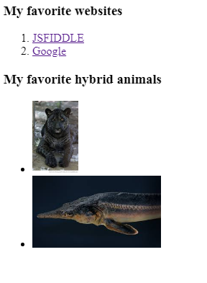

Part 2:

1. Which of the following makes comments for Javascript:

|  |  |
| --- | --- |
| <!-- ->  /**/ | <!-- -> |
| # | //  /**/ |
| “”” “”” | “”” “””  # |
| “” | -> |

1. Which of the following generates a random integer in javascript:

|  |  |
| --- | --- |
| Math.integer() | ˜ ˜(Math.random() * 1000) |
| parseInt(Random()) | Math.random() |
| Math.random() * 1000 | Randint() |
| Integer() | Random integer() |